

**National University of Computer and Emerging Sciences**

FYP Proposal Document

**“MedTrove”**

**(Development)**



**Group Members:**

Aliza Ibrahim 21I-0470

Kissa Zahra 21I-0572

Hamna Sadia Rizwan 21I-0603

**Supervisor:**

Mr. Bilal Khalid Dar

**Table of Contents**

Project Overview 3

Problem Statement 3

Problem Solution 3

Goals 4

Project Scope 4

Modules 6

1. Medi-bot 6

2. Substitute Drug Identifier 6

3. Search and Recommendation 6

4. Substitute Comparison 6

5. Online Consultation 7

6. Payment 7

7. Donation 7

8. Drug Interaction Checker 7

9. Medication Reminder 7

10. Profile Management 8

Functional Requirements 8

1. (Module) Substitute Drug Identifier 8

2. (Module) Search and Recommendation 8

3. (Module) Drug Interaction Checker 9

4. (Module) Medication Reminder 9

5. (Module) Substitute Comparison 10

6. (Module) Profile Management 10

7. (Module) Medi-bot 10

8. (Module) Payment 11

9. (Module) Donation 12

10. (Module) Online Consultation 12

Non-Functional Requirements 13

● Performance 13

● Usability 13

● Reliability 13

Process Flow 13

Flow Diagram 14

Involved Tools and Technologies 14

Involved Languages 14

Involved Tools 15

Involved Technologies 16

Timeline and Work Division 17

Conclusion 18

References 19

**List Of Figures**

Figure 1: Process Flow Diagram for MedTrove 14

Figure 2: Tools, Technologies and Expertise 17

Figure 3: Timeline and Work Division Gantt Chart 18

# 

# Project Overview

## Problem Statement

**“Healthcare should be a human right and not a commodity for sale.”**

**- Jim Wallis**

Unfortunately, the capitalisation of healthcare has become a pressing concern. In 2019, Drug Regulatory Authority of Pakistan (DRAP*)* had approved the increase of the prices of medicines by up to 15 percent. Hardship medicines which include medicines for heart patients and diabetics have increased up to 200%. [1]. In 2024, this trend continued as the caretaker federal cabinet approved a further increase in prices of an approximate 146 critical medications. [2]

The majority of these medicines account for diabetes and heart diseases which also happen to be the more common issues a regular Pakistani faces. 26.7% of Pakistanis are affected by diabetes. [3]whereas 29% of deaths in Pakistan are due to heart diseases. [4]

It is absolutely imperative to also note that as of 2024, 40% of Pakistanis now live below the poverty line according to the World Bank making it even more difficult to afford life-saving medication. [5]

With sky high inflation rates and the tradition of bribery between doctors and pharmaceutical companies disguised as “academic activities “to manipulate doctors into prescribing overpriced medications, innovative solutions are required to bridge the gap between Pakistanis and their right to affordable healthcare. [6]

## Problem Solution

Our proposed solution to the problem statement above is MedTrove, a mobile application designed to empower underprivileged individuals by making medications more accessible and affordable. Creative solutions are desperately needed as evidenced by the recent approval of outrageous price increases for essential medications such as diabetes and heart disease, as well as the ever-expanding poverty line. [4] [5]

MedTrove will address this challenge by allowing users to search for cost-effective alternatives based on the active ingredients of medications. This feature enables individuals to find cheaper options without compromising on quality, and also reducing the financial burden associated with chronic health conditions. By promoting transparency in drug pricing and leveraging technology to provide essential health services, MedTrove will not only improve access to healthcare but also contribute to poverty alleviation by empowering individuals to manage their health effectively.

The app will also allow users the ability to consult with our available doctors by booking online consultations. Additionally, to enhance the user experience and ensure medication adherence MedTrove will allow to check for interactions between multiple drugs, providing personalised health insights such as reminders for medication that will help users to stay on track with their treatments.

# Goals

* Streamlined medication management
* Informed decision making
* Personalised health insights

# Project Scope

MedTrove will be a cross-platform application that users can download onto their mobile device. Upon a successful download, users will be able to open the app and create their account or login. After doing so, users will land on their main dashboard.

If the user decides to manage their profile, they can change their credentials, profile picture, delivery address and save it. An option to delete the account from our database is also available.

If the user decides to search for some medication, they may get recommended searches based on their previous search/order history and an option to view alternative medication of their desired choice. The results will provide information in a list form, showcasing the name of the medication, formula, the alternatives and price. The user may select one to view detailed information such as side effects, usage instructions including dosage, warnings, details on the diseases it is used to treat and compare it with other alternatives. An add to cart option is available on the side for buying purposes.

Once they are finished, the user can checkout and begin the payment process. Payment can be made either by credit/debit card or JazzCash. Once completed, a verification message will pop up and the order will be dispatched.

Alternatively, the user may also choose to check for drug interactions using our drug interaction check feature. For this, the user must enter two different types of medication and the result will be whether or not such medication can be taken together at once.

MedTrove also provides a chatbot called Medibot which will provide preliminary medical advice, information about medication and help break down technical jargon doctors use in a friendly, conversational manner to ensure users can stay up to date with their health.

On the other hand, an online consultation service is also available where users can book video consultations with real life doctors’ part of our organisation.

Finally, if the user has the means and is willing to, they can provide donations. MedTrove uses donations to help provide those who may not have the means to pay for their medication, on our platform.

# Modules

We have 10 different modules in our project, which are as follows:

## Medi-bot

This module is designed to provide users with instant access to preliminary advice and detailed information about medications. This AI-powered assistant enhances user engagement by offering real-time guidance.

## Substitute Drug Identifier

This module is designed to help users find cost effective alternatives to their prescribed medications. This module leverages a comprehensive drug database to identify and suggest substitute drugs based on salt composition.

## Search and Recommendation

This module uses algorithms to analyse user search queries and previous orders to deliver recommendations to cater to the user’s specific needs. Along with this it will also show the searched medication if available.

## Substitute Comparison

This module is designed to provide users with a detailed analysis of a possible substitute medication. This module compares alternative medication based on several critical factors, enabling users to make informed decisions.

## Online Consultation

This module is designed to provide users with the convenience of booking and attending virtual appointments with doctors. This module will make it easier to manage their health from the comfort of their homes.

## Payment

This module is designed to facilitate secure financial transactions for purchasing medications. This module will ensure a streamlined checkout process and robust security features to protect user data.

## Donation

This module is designed to help pay for users in need. This module will allow users to contribute into a fund that will be used to provide discounted medications for underprivileged individuals.

## Drug Interaction Checker

This module will analyse the interactions between two medications and evaluate whether they are safe to take at a time or not, hence ensuring user safety by avoiding harmful side effects.

## Medication Reminder

This module is designed to assist users in managing their medication schedules effectively. This module will provide timely reminders and notifications to ensure that the users take their prescribed medication and stay on top of their treatment plans.

## Profile Management

This module is designed to provide users with a secure platform for managing their personal information. This module will allow users to customise their profiles, manage their health data and access services efficiently.

# Functional Requirements

## (Module) Substitute Drug Identifier

* The system shall allow users to input the name of the prescribed medication.
* The system shall access a drug database.
* The system shall identify alternative medicines with similar ingredients.
* The system shall compare alternative drugs based on price.
* The system shall display a list of alternative drugs, ranked by relevance.
* The system shall display detailed information on each alternative drug, including name, active ingredients, dosage, side effects and price.
* The system shall give the option to buy the alternative drug.
* The system shall display disclaimers advising users to consult healthcare professionals before making any medication changes.

## (Module) Search and Recommendation

* Users shall be able to search for medicines by entering the name of the medication.
* The system shall provide autocomplete suggestions as users type their search queries.
* The system shall allow filtering of search results based on criteria such as price, form, dosage, and brand.
* The system shall give the option to buy the medicine.
* The system shall provide recommendations to users based on previous searches and orders.
* The system shall update recommendations in real-time as new data from searches and orders become available.
* The system shall display search results and recommendations in a clear and user-friendly manner.

## (Module) Drug Interaction Checker

* The system shall allow users to input the name of two medications.
* The system shall access a drug interaction database.
* The system shall classify interactions based on severity, such as minor, moderate, and major.
* The system shall display whether the medications can be taken together or not.

## (Module) Medication Reminder

* The user shall be able to set a medication schedule.
* The system shall allow users to input medication details, including the name, dosage, frequency, and timing.
* The system shall enable users to set up recurring reminders based on daily, weekly, or custom schedules.
* The system shall provide timely reminders and notifications to the user.
* The system shall allow users to set a new alert time.
* The system shall provide options to reschedule missed doses and adjust future reminders accordingly.
* The system shall maintain a log of medication intake, including date and time of each dose taken.

## (Module) Substitute Comparison

* The system shall allow users to input the name of the prescribed medication they want to compare substitutes for.
* The system shall do a comparison between alternative medications based on price, potential side effects, dosage strength, brand and availability.
* The system shall highlight key differences between the prescribed medication and its respective substitutes.

## (Module) Profile Management

* The system shall allow new users to register by providing personal details such as name, email, phone number, and password.
* The user shall be able to login using their email address and password.
* The system shall allow users to input and update personal information such as name, date of birth, gender, contact information, and address.
* The system shall enable users to upload and update profile pictures.
* The system shall ensure the privacy and security of user data, complying with relevant regulations and standards.
* The system shall notify users of important updates or changes to their profile information.

## (Module) Medi-bot

* The system shall provide a user-friendly interface for initiating and conducting conversations with the chatbot.
* The user shall be able to enter medical questions in the chat.
* The system shall provide preliminary medical advice on common health issues based on user input.
* The system shall provide information about medication including recommended dosage and side effects.
* The system shall guide users on when to seek professional medical help for their symptoms.

## (Module) Payment

* The system shall require users to log in before accessing the payment features.
* The system shall allow users to select their preferred payment method, including credit/debit cards and JazzCash.
* The system shall provide an option to save payment information for future use.
* The system shall display an order summary before confirming the payment.
* The system shall send a confirmation notification to the user upon successful payment.
* The system shall maintain a record of all user transactions.
* The system shall integrate with the User/Profile Management module to retrieve saved payment information.
* The system shall integrate with the Donation module to facilitate donations as part of the payment process.
* The system shall notify users of successful payments, failed transactions, and any other payment related updates via email or notifications.

## (Module) Donation

* The system shall allow users to make monetary donations through various payment methods, including credit/debit cards and digital wallets.
* The system shall track all donations made by users, including the amount, date, and payment method.
* The system shall provide users with a history of their donations.
* The system shall allow allocation of donated funds to discount orders for underprivileged users.
* The user shall fill a form to prove their eligibility for discounts and funds.
* The system shall verify the eligibility of an underprivileged user through the filled form.

## (Module) Online Consultation

* The system shall allow users to register for online consultations using their email address and password.
* The system shall allow users to search for healthcare professionals based on specialty.
* The user shall be able to book an online consultation with a selected healthcare professional.
* The system shall display available time slots for each doctor, allowing users to choose the convenient time.
* The system shall allow users to specify the type of consultation (video, audio, or chat).
* The system shall provide a user-friendly interface for conducting online consultations.

# Non-Functional Requirements

## Performance

* + The application shall load within 4 seconds.
  + Medicine results shall be displayed within 5 seconds.

## Usability

* + The user interface shall be easy to navigate.
  + There shall be at least 2 helping screens between each frame.

## Reliability

* + The system shall have an uptime of 95%.
  + Backups and recovery mechanisms shall be implemented to prevent data loss.

# Process Flow

Our mobile app, MedTrove, will be designed using the Model-View-Controller (MVC) architecture to provide a personalised experience for each user.

The Model would manage the app's data, the View would display this data in a user-friendly way on the mobile screen, and the Controller would handle user input and update the Model and View for each user. This approach will allow the app to be easily customised to fit each user's needs or requests.

With MVC, patients can see simplified information. This will ensure a smooth and responsive experience, helping users find affordable medicines, talk to our medi-bot, get online consultations, and manage their health easily.

## Flow Diagram

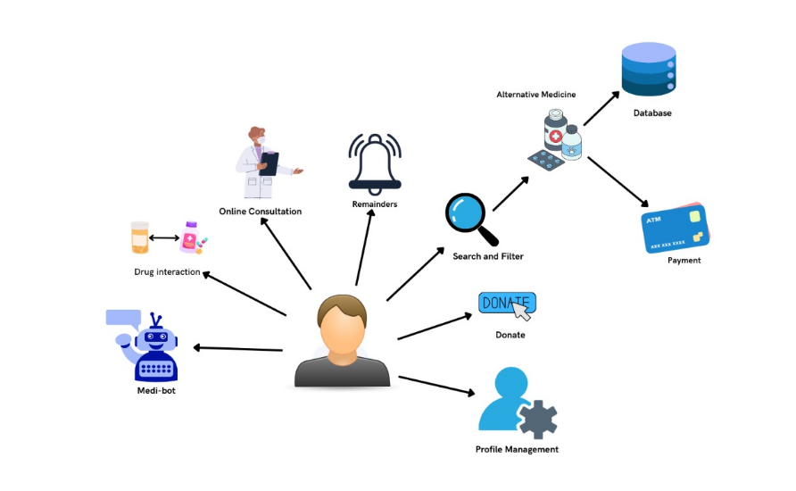

Figure 1: Process Flow Diagram for MedTrove

# Involved Tools and Technologies

Based on our learning and research up till now these are the tools, technologies and languages we might use:

## Involved Languages

* **JavaScript:** A versatile scripting language primarily used for web development. It allows the creation of dynamic and interactive web pages which will help us to enhance user interactivity and experience. The extensive available libraries and frameworks such as React and Node.js will allow us full stack development (both client and server side).
* **HTML:** The standard markup language for creating web pages. HTML allows developers to structure content, its semantic tags ensure that the web content is accessible and well-organised.
* **CSS:** The language used to style a web page, it controls the layout, colours, font and overall visual appearance of web pages. CSS will help us to create a responsive design to ensure that applications are aesthetically pleasing and functional across various devices and screen sizes.

* **Python:** A high-level programming language with extensive standard libraries and community-supported libraries make it ideal for a wide range of applications including artificial intelligence.
* **SQL:** Structured query language (SQL) is a programming language for storing and processing information in a relational database. With its powerful querying capabilities this language will help us to ensure efficient data retrieval and management.

## Involved Tools

* **IDE: Visual Studio Code:** A lightweight code editor redefined and optimised for building and debugging applications, all while supporting a variety of languages. It offers features such as syntax highlighting and an elaborate library of extensions which makes it ideal for our use in building a mobile application.
* **Version Control: Github:** A widely-used control platform used for collaboration among developers. Github enables tracking changes and managing code repositories, which will help us in work division and integration on our chosen IDE VS Code.
* **Project Management: Trello:** A project management tool that uses boards, lists and cards to help teams organise tasks. Trello’s easy to use interface will allow for easy management of workflows and deadlines, ensuring that the team stays on schedule.
* **Database Management: MongoDB, MS SQL:** These platforms will be used to maintain databases of our system. They are designed for scalable data storage and to handle large amounts of unstructured data.
* **UI/UX Design: Figma:** A collaborative UI/UX design tool that enables teams to design, prototype and share user interfaces. Figma’s real-time collaboration will allow us to work together in a stream-lined fashion for our design process of the app.

## Involved Technologies

|  |  |  |  |
| --- | --- | --- | --- |
| **Tools & Technologies** | **Kissa Zahra** | **Aliza Ibrahim** | **Hamna Sadia Rizwan** |
| **React Native** | **3** | **3** | **3** |
| **MERN** | **7** | **5** | **7** |
| **Figma** | **8** | **8** | **8** |
| **Database** | **7** | **8** | **8** |
| **Python** | **6** | **6** | **6** |
| **NLP** | **2** | **2** | **3** |
| **Data Security** | **4** | **5** | **5** |
| **Authentication** | **3** | **4** | **4** |
| **APIs** | **2** | **6** | **3** |
| **MS Excel** | **9** | **9** | **9** |
| **MS PowerPoint** | **9** | **9** | **9** |
| **Github** | **7** | **8** | **7** |
| **MS Word** | **9** | **9** | **9** |

Figure 2: Tools, Technologies and Expertise

# 

# Timeline and Work Division

Our project is divided into four iterations, with first iteration being from August to

October, the next from November to January, then the third iteration from February to April and lastly, the fourth from May to July.

All implementations are done by all the group members!

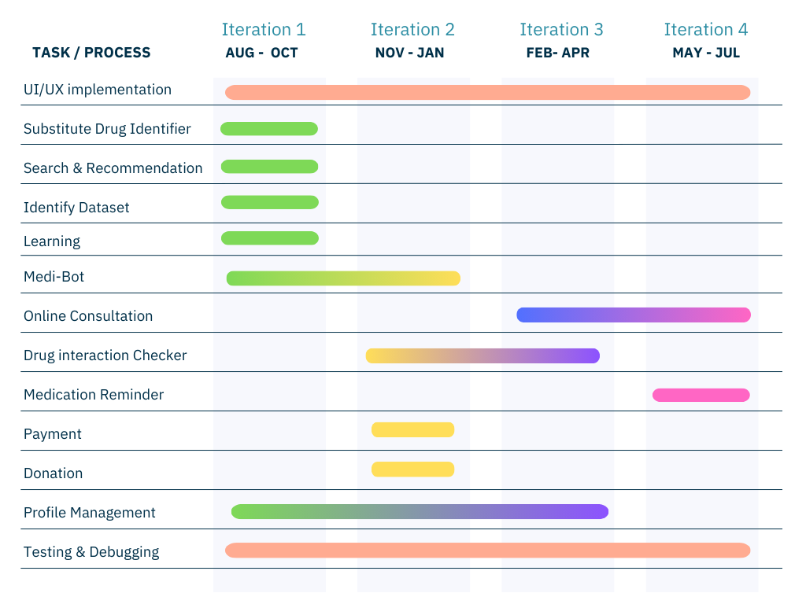

Figure 3: Timeline and Work Division Gantt Chart

# Conclusion

As medical prices continue to hike, we aim to make MedTrove a ray of hope for those struggling to finance their medical costs. By employing technologies such as NLP and predictive analysis, MedTrove aims to empower users with medical accessibility and knowledge to make informed decisions regarding their healthcare whilst ensuring compliance with the health regulatory policies set in place.

As passionate developers, driven to making a difference, we sincerely believe that under the guidance of our esteemed supervisor, Sir [Bilal Khalid Dar](mailto:bilal.khalid@nu.edu.pk), MedTrove will contribute to a healthier future for our country, Pakistan.

# References

|  |  |
| --- | --- |
| [1] | F. Durrani, “Increase in drug prices highest in last 40 years,” 8 April 2019. [Online]. Available: https://www.thenews.com.pk/print/454864-increase-in-drug-prices-highest-in-last-40-years. [Accessed 12 July 2024]. |
| [2] | “Govt approves increase in prices of 146 essential life-saving medicines,” 1 February 2024. [Online]. Available: https://www.dawn.com/news/1810395. [Accessed 12 July 2024]. |
| [3] | “The increasing rate of diabetes in Pakistan: A silent killer,” [Online]. Available: https://www.ncbi.nlm.nih.gov/pmc/articles/PMC9289249/. [Accessed 12 July 2024]. |
| [4] | I. Junaidi and R. Zakaria, “'47 people die of heart attack every hour in Pakistan',” 30 September 2021. [Online]. Available: https://www.dawn.com/news/1649189. [Accessed 12 July 2024]. |
| [5] | “PAKISTAN: Implementing an Ambitious, Credible and Clearly Communicated Economic Reform Plan Critical for Robust Recovery, Poverty Reduction, says World Bank,” 2 April 2024. [Online]. Available: https://www.worldbank.org/en/news/press-release/2024/04/01/pakistan-implementing-an-ambitious-credible-and-clearly-communicated-economic-reform-plan-critical-for-robust-recovery-p. [Accessed 12 July 2024]. |
| [6] | Dawn, “Big Pharma and Physicians,” 6 October 2008. [Online]. Available: https://www.dawn.com/news/845158/big-pharma-and-physicians. |